实验编号： 9 **四川师大《IOS》实验报告 2018** 年 **11** 月 **7** 日

### **计算机科学学院** 2016 级 4 班 实验名称： Gesture、UIAlertController、 ScrollView

姓名：_谭靖薇_ 学号：_2016110437 指导老师：__李贵洋__ 实验成绩:_____

**实验 九 _____** Gesture、UIAlertController、 ScrollView **_______**

1. 实验目的及要求
2. 理解并掌握iOS多点手势识别的相关技术；
3. 实验要求
4. 认真填写实验报告，要求附加部分运行界面和主要代码；
5. 对设计好的程序，检查输出是否符合预期，如有错请分析错误原因并解决；
6. 实验内容
7. Gesture
   1. 分别采用代码随机位置大小生成和直接拖拽的方式产生多个视图；
   2. 采用简单的动画进行移动；
   3. 给视图加上阴影(layer)；
   4. 可全部清空子视图；
   5. 视图支持手势（pan移动、tap删除、pinch缩放、rotation旋转）；

提示：Pinch的scale属性可用于调整frame

rotation需要用transform属性实现

1. 实现UIAlertController交互
   1. 显示ActionSheet并进行交互；
   2. 显示Login Alert并进行交互；
2. 一个界面使用两个scrollView
   1. 在一个scrollView中可进行多张图片横屏滚动浏览(相册)，需要有pagecontrol进行提示；
   2. 在另一个scrollView中可放大缩小；

提示：需用delegate

1. 实验主要流程、基本操作或核心代码、算法片段（该部分如不够填写，请另加附页）
2. Gesture
   1. 分别采用代码随机位置大小生成和直接拖拽的方式产生多个视图；
   2. 采用简单的动画进行移动；
   3. 给视图加上阴影(layer)；
   4. 可全部清空子视图；
   5. 视图支持手势（pan移动、tap删除、pinch缩放、rotation旋转）；

提示：Pinch的scale属性可用于调整frame

rotation需要用transform属性实现

* 程序代码：

*CircleView*

*//*

*// CircleView.swift*

*// gesture*

*//*

*// Created by student on 2018/11/21.*

*// Copyright © 2018年 tan. All rights reserved.*

*//*

**import** UIKit

**@IBDesignable**

**class** CircleView: UIView {

**var** netRotation:CGFloat = 1.0 *//旋转*

**@IBInspectable** **var** fillColor:UIColor?

**@IBInspectable** **var** strokeColor:UIColor?

**func** setup() {

**let** panRecongnizer = UIPanGestureRecognizer(target: **self**, action: **#selector**(pan(recognizer: )))

**self**.addGestureRecognizer(panRecongnizer)

**let** pinchRecongnizer = UIPinchGestureRecognizer(target: **self**, action: **#selector**(pinch(recognizer: )))

**self**.addGestureRecognizer(pinchRecongnizer)

**let** tapRecongnizer = UITapGestureRecognizer(target: **self**, action: **#selector**(tap(recognizer: )))

**self**.addGestureRecognizer(tapRecongnizer)

**let** rotationRecongnizer = UIRotationGestureRecognizer(target: **self**, action: **#selector**(rotation(recognizer: )))

**self**.addGestureRecognizer(rotationRecongnizer)

tapRecongnizer.numberOfTouchesRequired = 1

tapRecongnizer.numberOfTapsRequired = 2

}

**@objc** **func** rotation(recognizer: UIRotationGestureRecognizer){

**switch** recognizer.state {

**case** .changed:

**fallthrough**

**case** .ended:

**let** rotation:CGFloat = recognizer.rotation

**self**.transform = CGAffineTransform(rotationAngle: rotation+netRotation)

netRotation+=rotation

**default**:

**break**

}

}

**@objc** **func** pan(recognizer: UIPanGestureRecognizer){

**switch** recognizer.state {

**case** .changed:

**fallthrough**

**case** .ended:

**let** translation = recognizer.translation(in: **self**)

center.x += translation.x

center.y += translation.y

recognizer.setTranslation(.zero, in: **self**)

**default**:

**break**

}

}

**@objc** **func** pinch(recognizer: UIPinchGestureRecognizer){

**switch** recognizer.state {

**case** .changed:

**fallthrough**

**case** .ended:

bounds.size = CGSize(width: bounds.width*recognizer.scale, height: bounds.height*recognizer.scale)

recognizer.scale = 1

**default**:

**break**

}

}

**@objc** **func** tap(recognizer: UITapGestureRecognizer){

**switch** recognizer.state {

**case** .recognized:

print("double")

**default**:

**break**

}

}

**override** **init**(frame: CGRect) {

**super**.init(frame: frame)

setup()

}

**required** **init**?(coder aDecoder: NSCoder) {

**super**.init(coder: aDecoder)

setup()

}

**override** **func** draw(**_** rect: CGRect) {

**let** path = UIBezierPath(ovalIn: rect)

fillColor?.setFill()

strokeColor?.setStroke()

path.fill()

path.stroke()

}

}

ViewController

*//*

*// ViewController.swift*

*// gesture*

*//*

*// Created by student on 2018/11/21.*

*// Copyright © 2018年 tan. All rights reserved.*

*//*

**import** UIKit

**class** ViewController: UIViewController {

**override** **func** viewDidLoad() {

**super**.viewDidLoad()

*// Do any additional setup after loading the view, typically from a nib.*

}

**@IBAction** **func** addLabel(**_** sender: **Any**) {

**let** x = Int(arc4random()) % Int(view.bounds.width)

**let** y = Int(arc4random()) % Int(view.bounds.height)

**let** label = UILabel(frame: CGRect(x: x, y: y, width: 30, height: 30))

label.text = "A"

label.textAlignment = .center

label.backgroundColor = UIColor.red

label.layer.shadowColor = UIColor.gray.cgColor

label.layer.shadowOffset = CGSize(width: 5, height: 5)

label.layer.shadowOpacity = 1

view.addSubview(label)

**let** panRecongnizer = UIPanGestureRecognizer(target: **self**, action: **#selector**(pan(recognizer: )))

label.addGestureRecognizer(panRecongnizer)

label.isUserInteractionEnabled = **true**

}

**@objc** **func** pan(recognizer: UIPanGestureRecognizer){

**switch** recognizer.state {

**case** .changed:

**fallthrough**

**case** .ended:

**let** translation = recognizer.translation(in: **self**.view)

recognizer.view?.center.x += translation.x

recognizer.view?.center.y += translation.y

recognizer.setTranslation(.zero, in: **self**.view)

**default**:

**break**

}

}

**@IBAction** **func** moveLabel(**_** sender: **Any**) {

**for** label **in** view.subviews{

**if** label **is** UILabel {

UIView.animate(withDuration: 1){

**let** x = Int(arc4random()) % Int(**self**.view.bounds.width)

**let** y = Int(arc4random()) % Int(**self**.view.bounds.height)

label.center.x = CGFloat(x)

label.center.y = CGFloat(y)

}

}

}

}

**@IBAction** **func** deleteLabel(**_** sender: **Any**) {

**for** label **in** view.subviews{

**if** label **is** UILabel {

label.removeFromSuperview()

}

}

}

}

* 运行结果：
* (1)缩小和放大

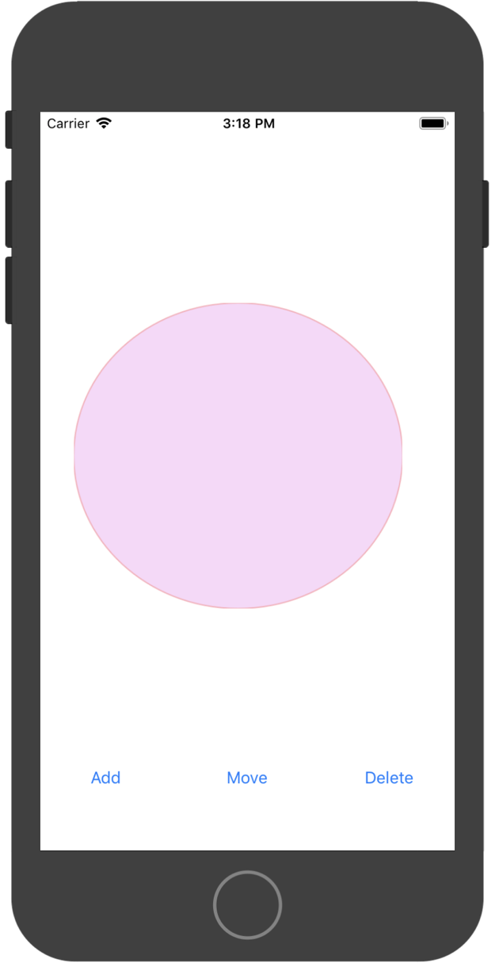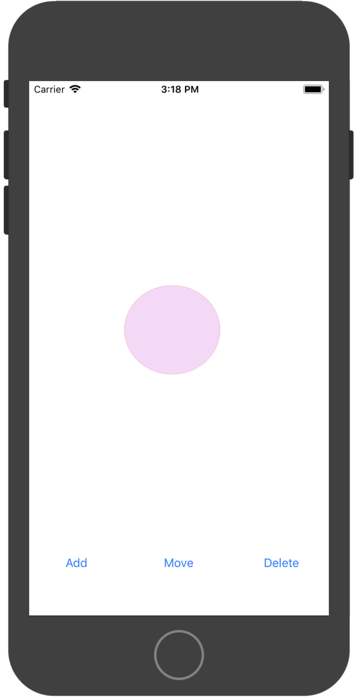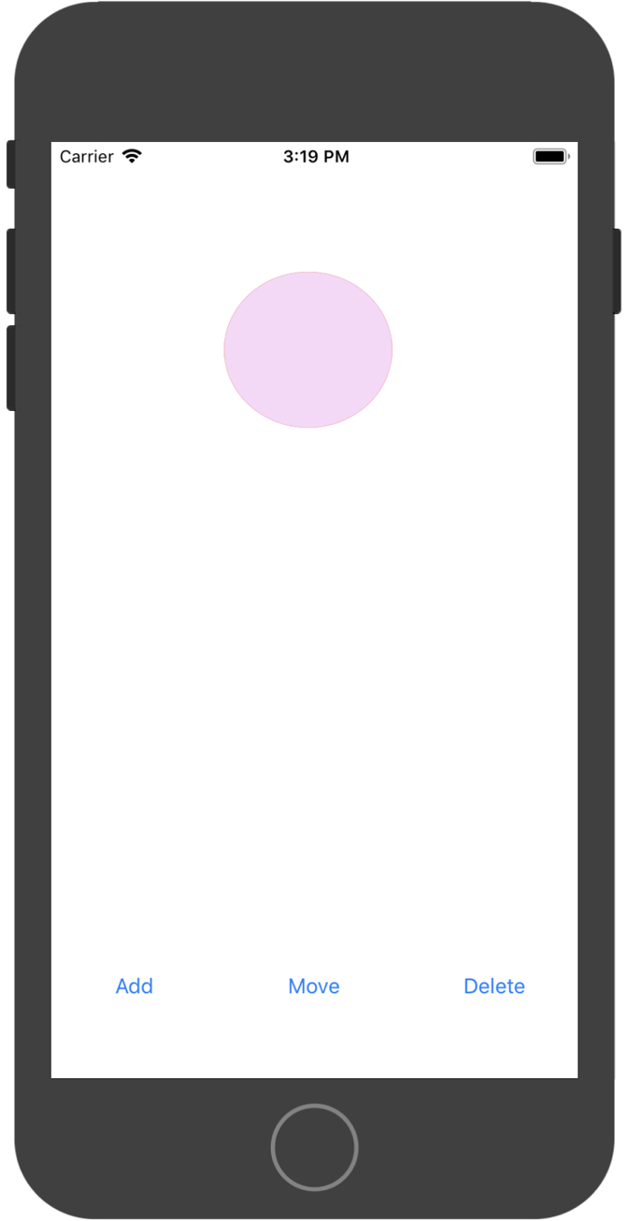

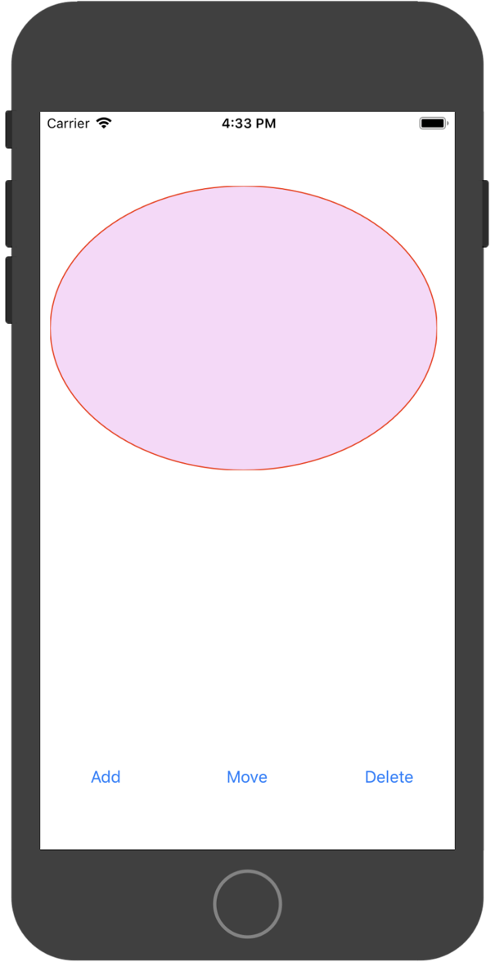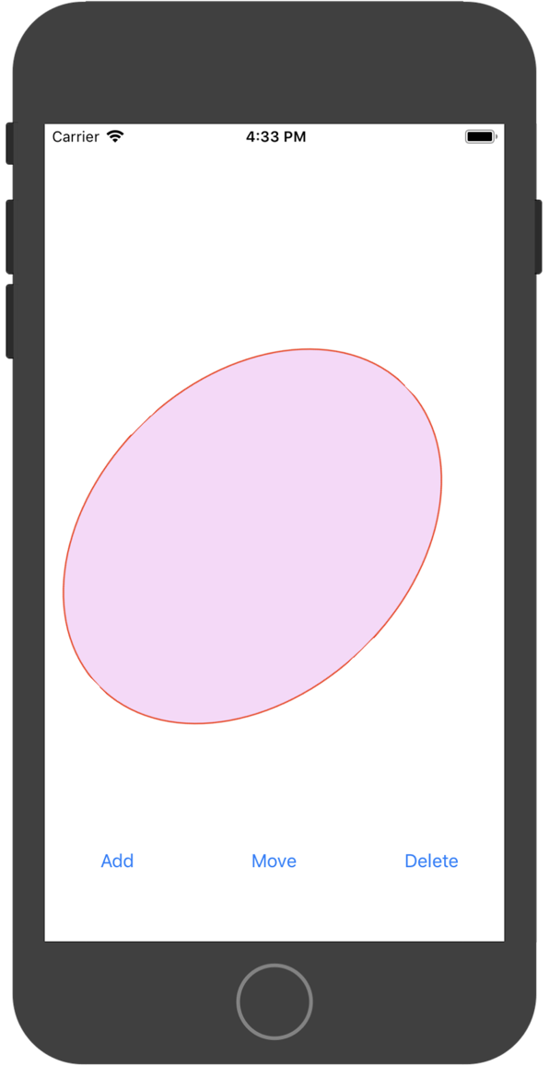

1. 实现UIAlertController交互
   1. 显示ActionSheet并进行交互；
   2. 显示Login Alert并进行交互；

* 程序代码：

Viewcontrolller

*//*

*// ViewController.swift*

*// alertController*

*//*

*// Created by student on 2018/11/7.*

*// Copyright © 2018年 tan. All rights reserved.*

*//*

**import** UIKit

**class** ViewController: UIViewController {

**override** **func** viewDidLoad() {

**super**.viewDidLoad()

*// Do any additional setup after loading the view, typically from a nib.*

}

**@IBAction** **func** actionSheet(**_** sender: **Any**) {

**let** alert = UIAlertController(title: "sction sheet", message: "this is an action alert", preferredStyle: .actionSheet)

alert.addAction(UIAlertAction(title: "green", style: .default, handler: {(action) **in**

print("ok clicked")

**self**.view.backgroundColor = UIColor.green

}))

alert.addAction(UIAlertAction(title: "red", style: .destructive, handler: {(action) **in**

print("destuctive clicked")

**self**.view.backgroundColor = UIColor.red

}))

alert.addAction(UIAlertAction(title: "gray", style: .cancel, handler: {(action) **in**

print("cancel clicked")

**self**.view.backgroundColor = UIColor.gray

}))

present(alert, animated: **true**, completion: **nil**)

}

**@IBAction** **func** login(**_** sender: **Any**) {

**let** alert = UIAlertController(title: "login", message: "please input your personal information", preferredStyle: .alert)

alert.addAction(UIAlertAction(title: "login", style: .default, handler: {(action) **in**

**if** **let** userNameTextField = alert.textFields?.first,

**let** passwordTextField = alert.textFields?.last {

print("username:\(userNameTextField.text!) password:\(passwordTextField.text!)")

}

}))

alert.addAction(UIAlertAction(title: "cancel", style: .cancel, handler: {(action) **in**}))

alert.addTextField { (textField) **in**

textField.placeholder = "your user name?"

}

alert.addTextField { (textField) **in**

textField.placeholder = "your password?"

textField.isSecureTextEntry = **true**

}

present(alert, animated: **true**, completion: **nil**)

}

}

* 运行结果：

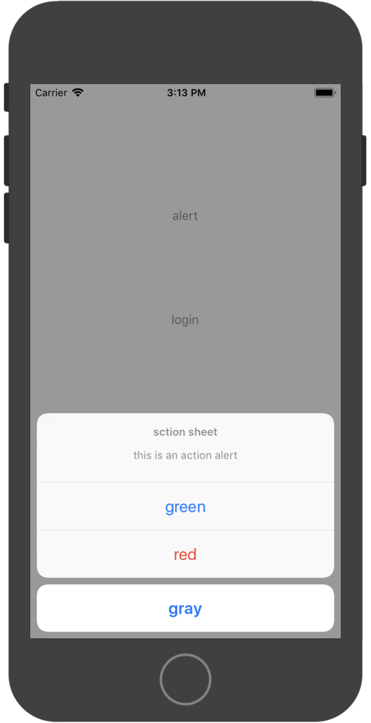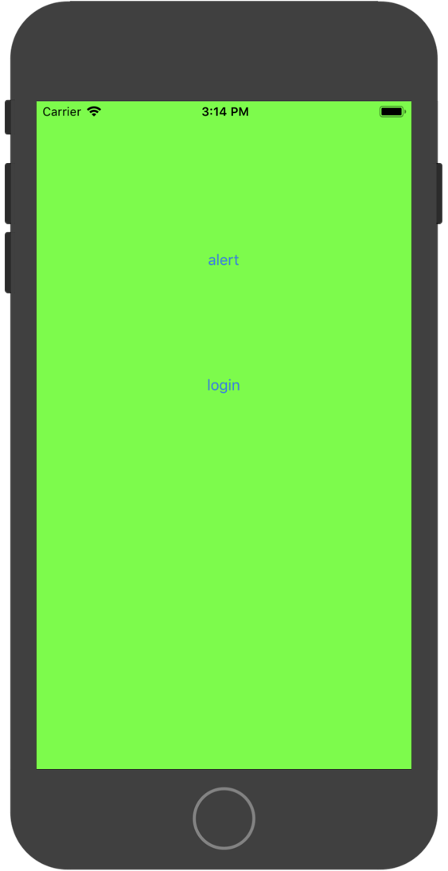

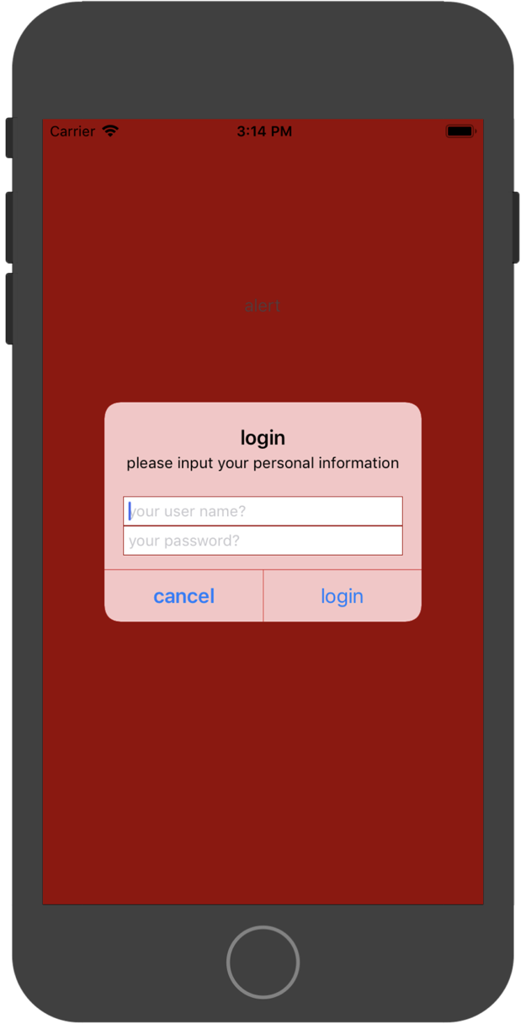

1. 一个界面使用两个scrollView
   1. 在一个scrollView中可进行多张图片横屏滚动浏览(相册)，需要有pagecontrol进行提示；
   2. 在另一个scrollView中可放大缩小；

提示：需用delegate

* 程序代码：

**import** UIKit

**class** ViewController: UIViewController,UIScrollViewDelegate {

**@IBOutlet** **weak** **var** scrollView: UIScrollView!

**@IBOutlet** **weak** **var** pageControll: UIPageControl!

**override** **func** viewDidLoad() {

**super**.viewDidLoad()

*// scrollView.minimumZoomScale = 0.2*

*// scrollView.maximumZoomScale = 5*

scrollView.delegate = **self**

**for** i **in** 1...7 {

**let** imageView = UIImageView(image: UIImage(named: "\(i)"))

imageView.contentMode = .scaleAspectFit

imageView.frame = CGRect(x: CGFloat(i-1) * scrollView.bounds.width, y: 0, width: scrollView.bounds.width, height: scrollView.bounds.height)

scrollView.addSubview(imageView)

}

scrollView.contentSize = CGSize(width: scrollView.bounds.width * 7, height: scrollView.bounds.height)

scrollView.isPagingEnabled = **true**

scrollView.showsHorizontalScrollIndicator = **false**

pageControll.numberOfPages = 7

pageControll.currentPage = 0

}

**@IBAction** **func** pageControllClicked(**_** sender: UIPageControl) {

**let** currentPage = sender.currentPage

**let** rect = CGRect(x: CGFloat(currentPage) * scrollView.bounds.width, y: 0, width: scrollView.bounds.width, height: scrollView.bounds.height)

scrollView.scrollRectToVisible(rect, animated: **true**)

}

**func** scrollViewDidEndDecelerating(**_** scrollView: UIScrollView) {

**let** currentPage = scrollView.contentOffset.x/scrollView.bounds.width

pageControll.currentPage = Int(currentPage)

}

}

* 运行结果：

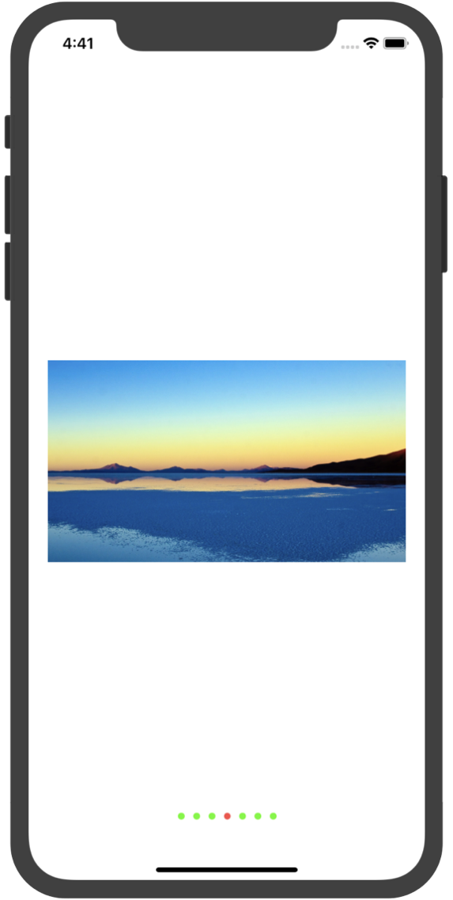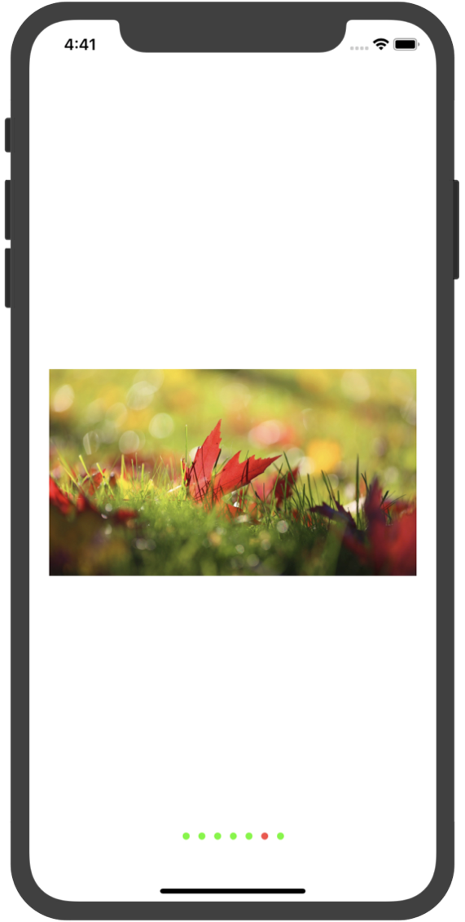

1. 实验结果的分析与评价（该部分如不够填写，请另加附页）

Github地址：

注：实验成绩等级分为（90－100分）优，（80－89分）良，(70-79分)中，（60－69分）及格，（59分）不及格。